**CHEG401 - Chemical Process Dynamics and Control**

**Lab 7 - Multivariable Control**

Li Pei Soh

Linh Nguyen

Khai Khee Kho

Abdul Fayeed Abdul Kadir

December 10th, 2021

College of Engineering, Department of Chemical and Biomolecular Engineering

University of Delaware

Newark, Delaware 19711

**6.1 Part I: Loop Pairing and Multiloop Control**

y1(s) = g11(s)u1(s)+ g12(s)u2(s)

y2(s) = g21(s)u1(s)+ g22(s)u2(s)

Nominal operating steady state conditions: Feed Rate, 29 lb/hr; Screw Speed, 530 rpm; corresponding to values of 210 psig for Die Pressure, and 126 Nm for Drive Torque.

1. **Loop Pairing**

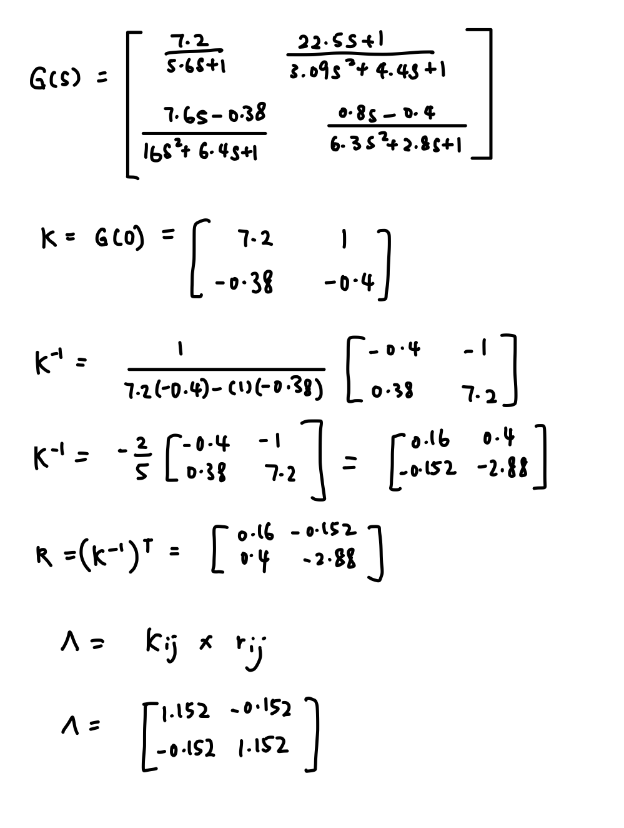

***(a) the appropriateness of the pairing prescribed in Lab 7? And***

The appropriate pairing is y1/m1 and y2/m2. This is because this set pairing has positive RGA elements. Although this pairing on RGA values greater than 1 is not desirable, the pair on a negative RGA is worse still. Die pressure was controlled by feed rate and drive torque was controlled by screw speed.

***(b) how well can you expect the two independent single-loop controllers to perform in light of the implied intrinsic loop interactions?***

This pairing on RGA values greater than 1 but very close to 1, the two independent single-loop controllers are expected to perform well. Decoupling can be used to improve the control system.

1. **Design and Implementation of Two Single-Loop Controllers’**

**Loop 1:**

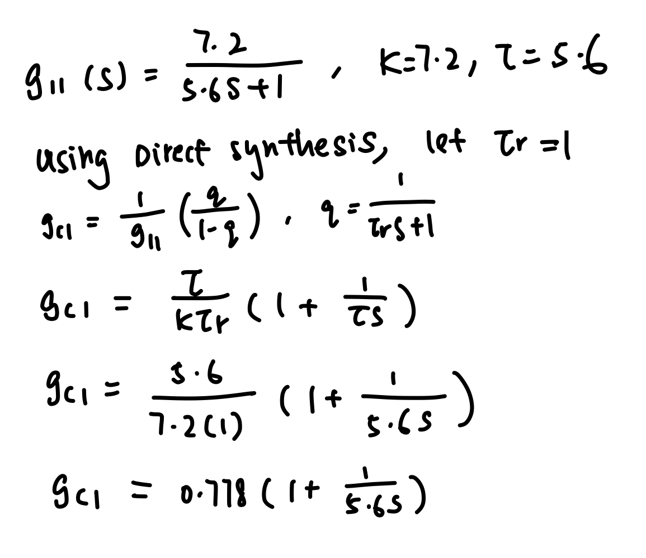

**Loop 2:**

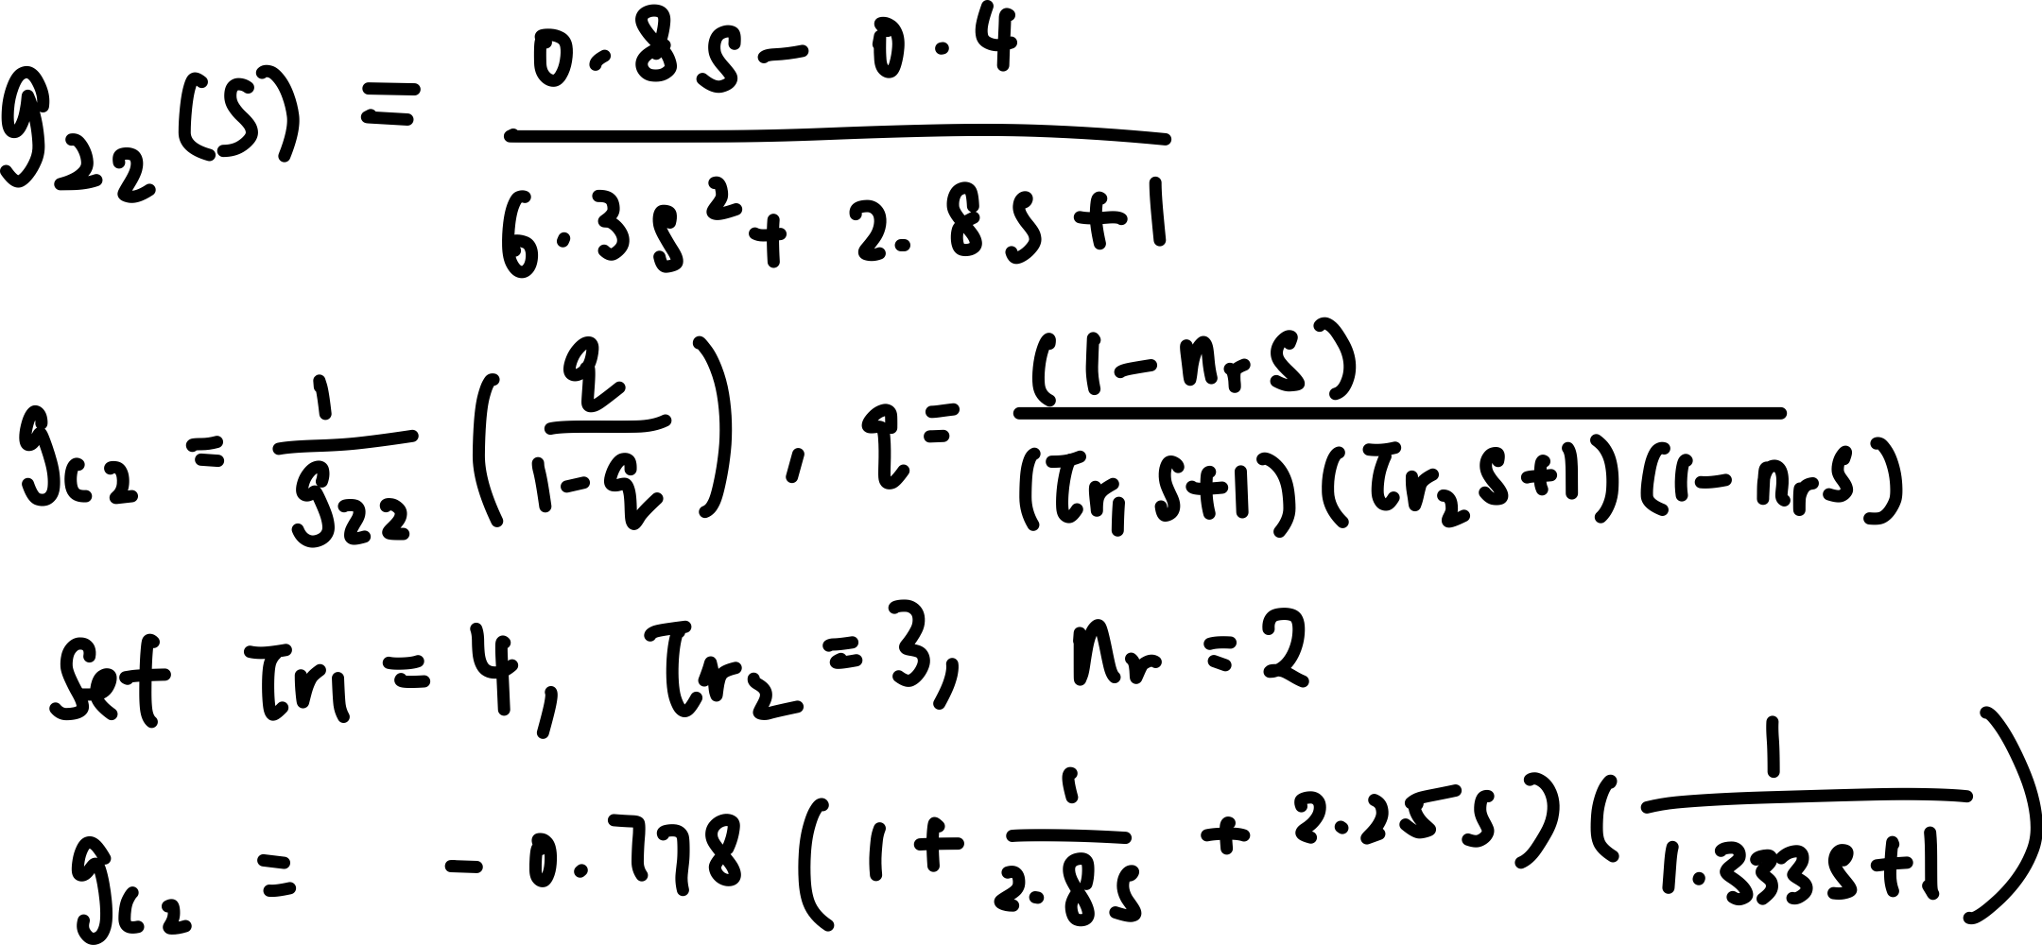

**Table 1.** Parameters for PID controllers of Loop 1 and Loop 2

|  | **Kc** | **𝝉I** | **𝝉D** |
| --- | --- | --- | --- |
| **Loop 1** | 0.778 | 5.6 | - |
| **Loop 2** | -0.778 | 2.8 | 2.25 |

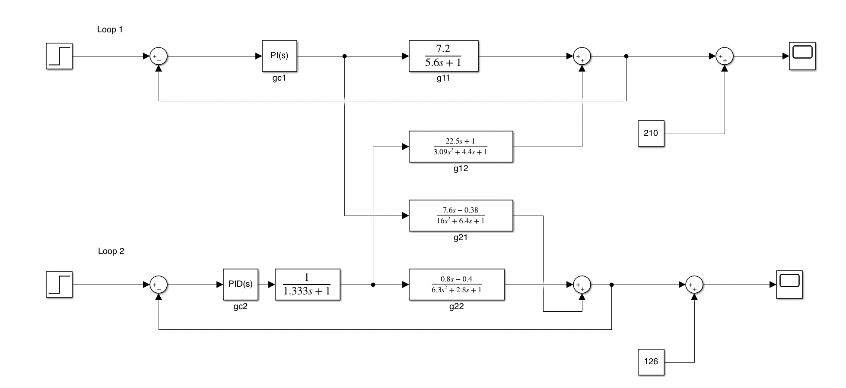

**Figure 1.** SIMULINK setup for the system

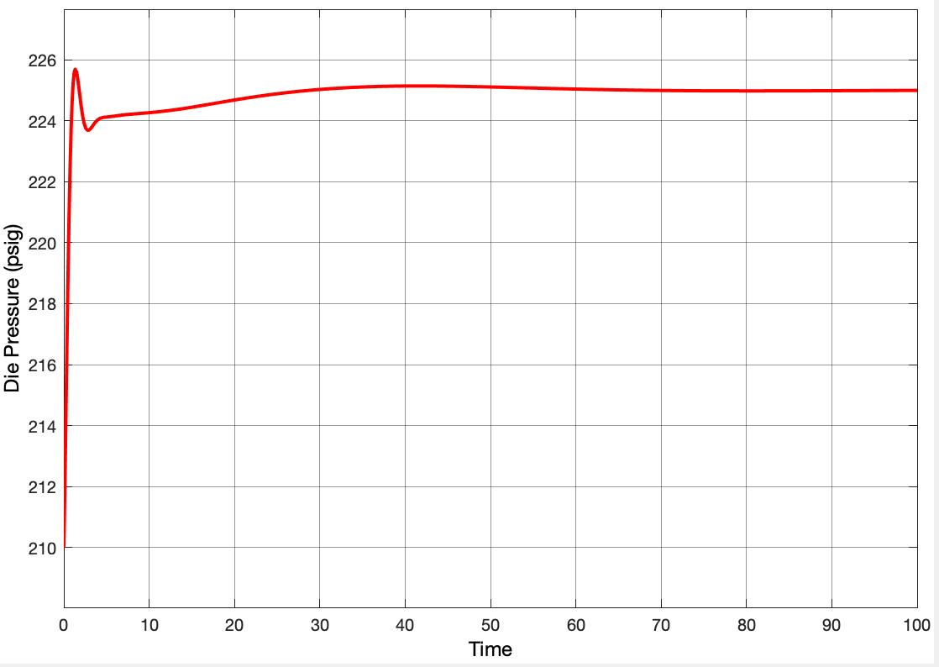

**Figure 2.**  Die pressure response

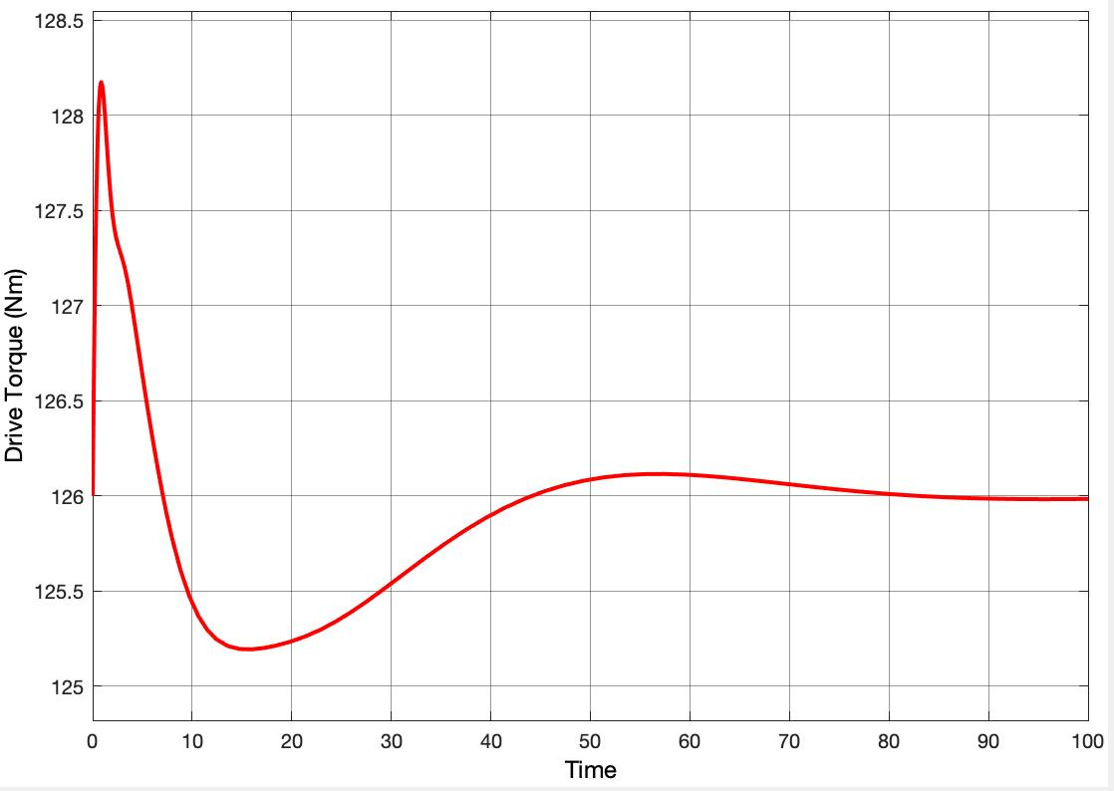

**Figure 3.** Drive torque response

Direct synthesis was used to design gc1 and gc2, shown above. 𝝉r value for both loop was set to small value for faster closed loop trajectory. The parameters for the PID controller for both loops was shown in Table 1. For loop 1, the controller was found to PI controller instead of PID controller after setting 𝝉r value to be 1. Based on Figure 2, die pressure reaches 225 psig at about t=50. The drive torque reaches 126 Nm at about t = 90. The time of increasing die pressure from its initial value to 225 psig can be shortened by implementing a decoupler which will be shown in Part II.

**6.2 Part II: Dynamic and Steady State Decoupling**

1. **Simplified Dynamic Decoupling**

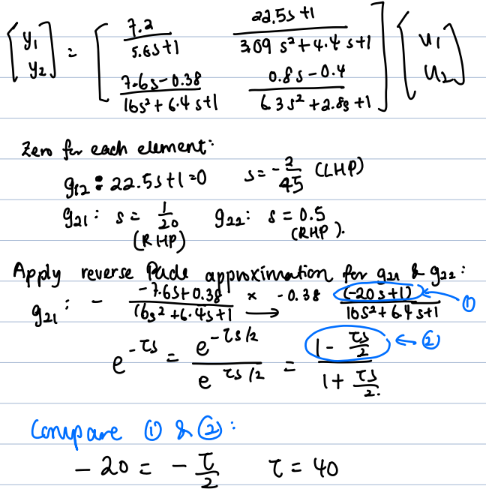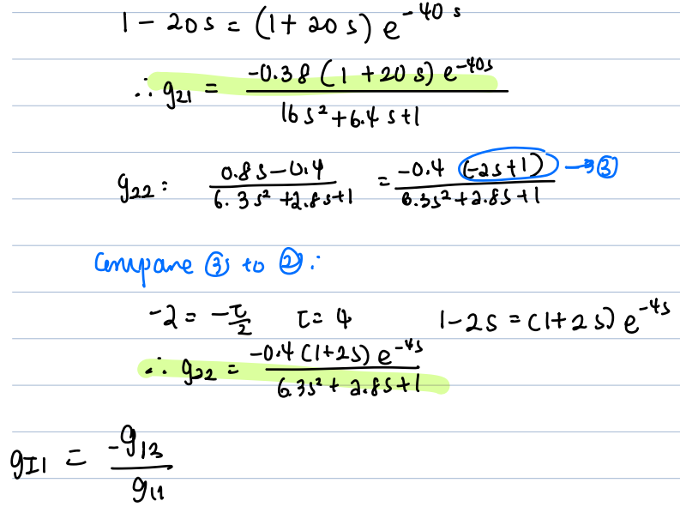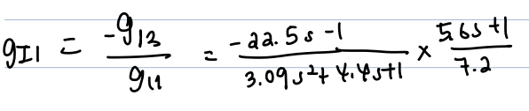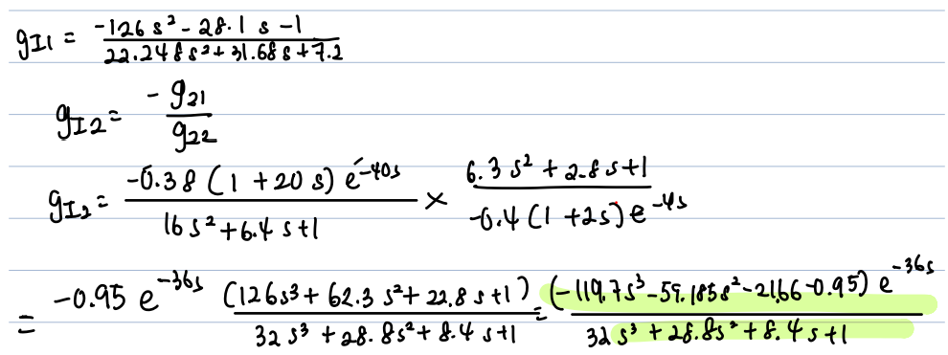

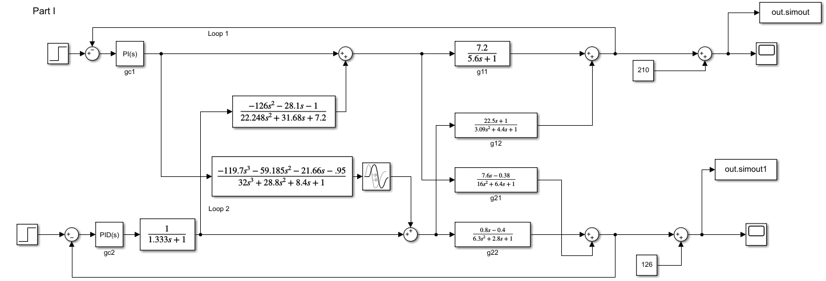

**Figure 4.**  Simulink setup for simplified dynamic decoupling

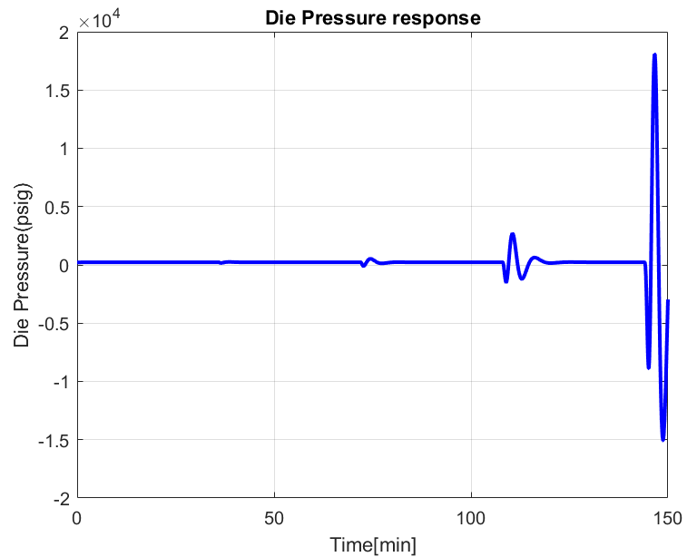

**Figure 5**. Die pressure response under dynamic decoupling

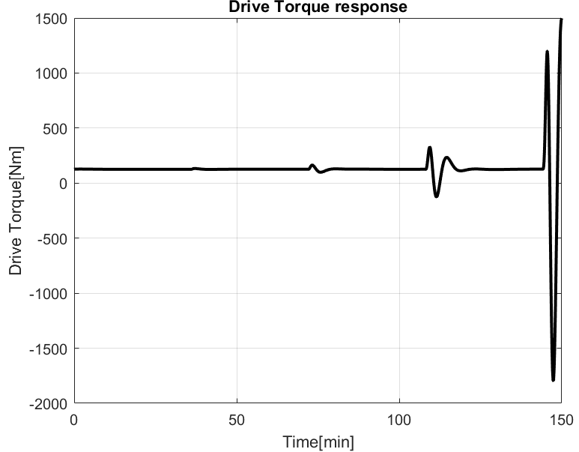

**Figure 6**. Drive torque response under dynamic decoupling

The response under dynamic decouplers fluctuates every certain period, so does not converge to steady state. Compared to the response in Part I, under dynamic decoupling effect, the responses seem to be worse although the decouplers were meant to help stabilize the response in the shorter period of time.

1. **Steady State Decoupling**

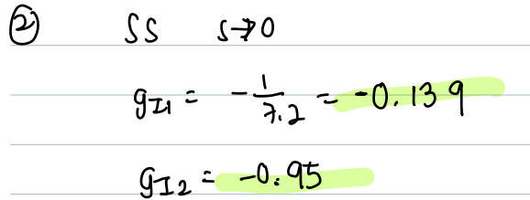

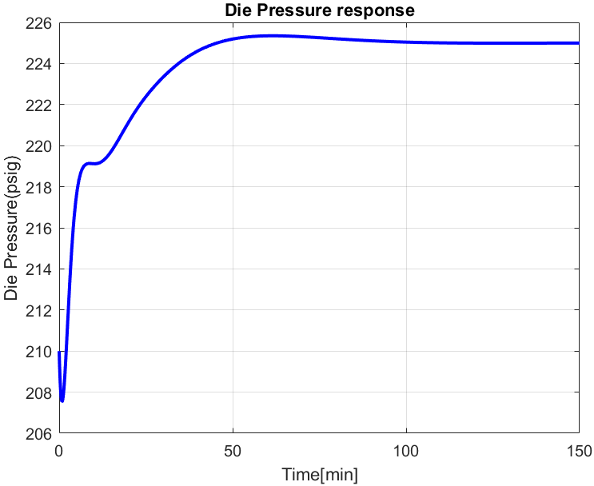

**Figure 7**. Die pressure response under steady state decoupling

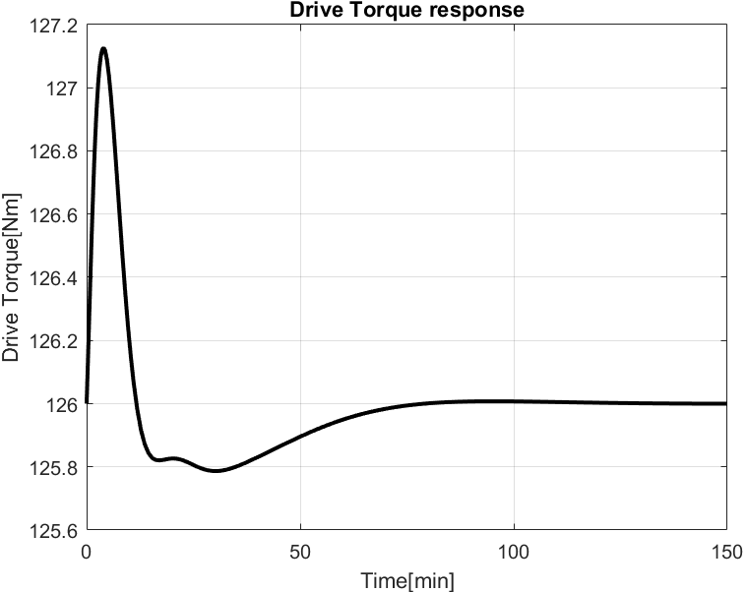

**Figure 8**. Drive torque response under steady state decoupling.

1. Based on **Figure 7** and **8**, although the die pressure responses reach steady state slower than that of the two independent single-loop controllers of part I; the drive torque response reaches steady state at about the same time as part I. The fluctuation in drive torque in Figure 8 is only slightly smaller than that of Part I. So, no significant advantage over part I single loop controller.
2. Dynamic decoupler did not perform as great as steady-state decoupler, which goes against what is predicted.
3. **Effect of Plant/Model Mismatch**

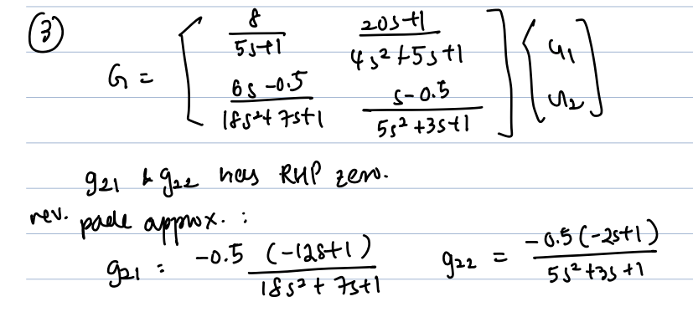

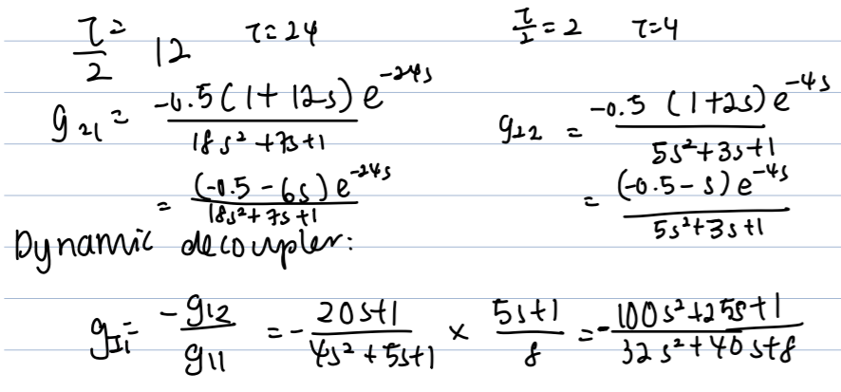

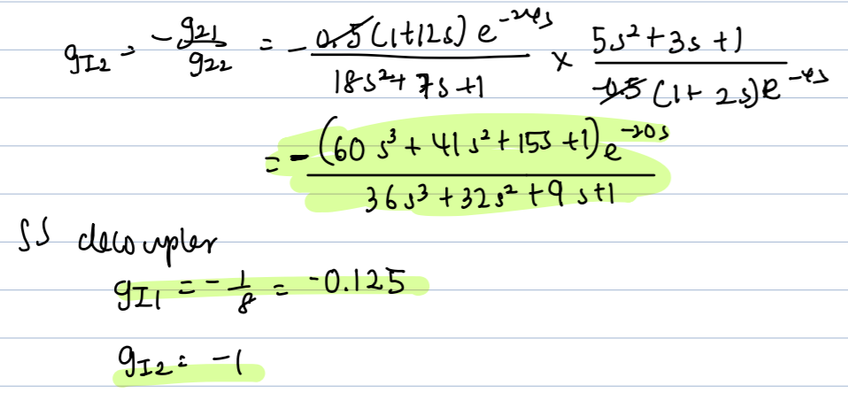

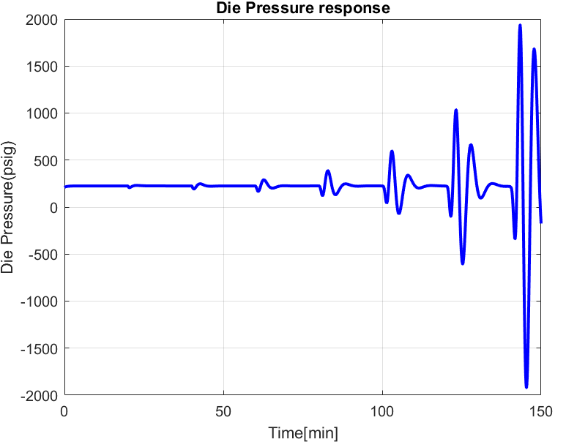

**Figure 9**. Die pressure response under dynamic decoupling

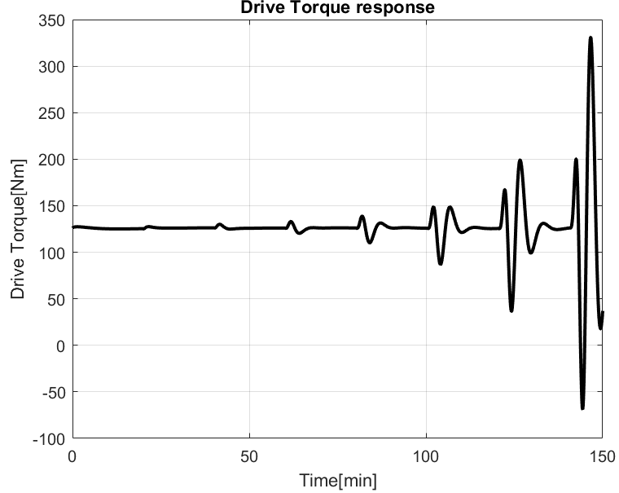

**Figure 10**. Drive torque response under dynamic decoupling.

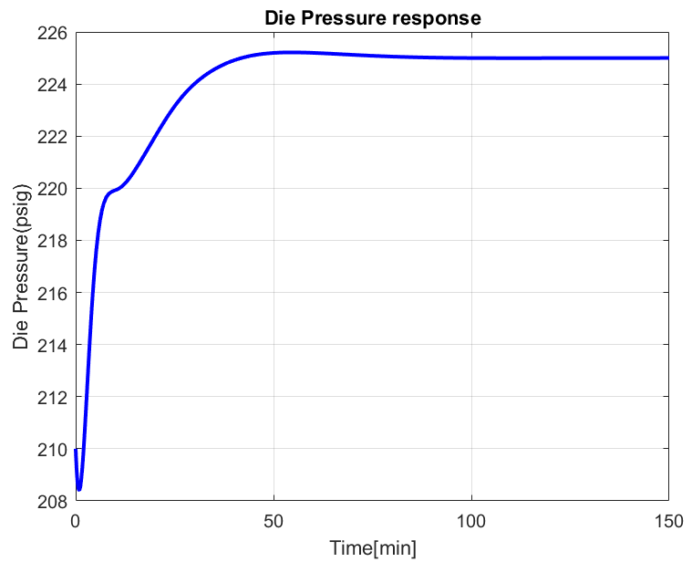

**Figure 11**. Die pressure response under steady state decoupling

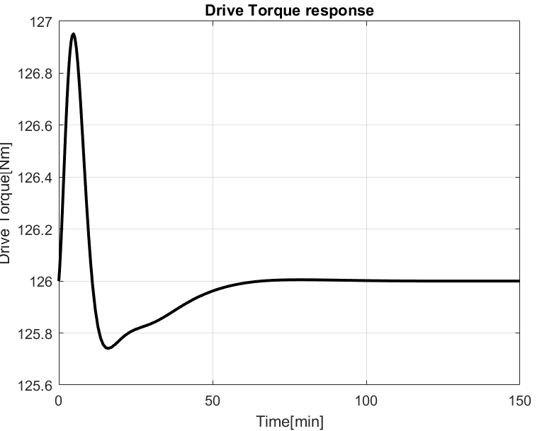

**Figure 12**. Drive torque response under steady state decoupling.

For both the dynamic and steady state decoupling strategy, the “true plant” model has an overall better performance, compared to the model from Part II Question 1 and 2, because this “true plant” model gives less fluctuations. Steady state decoupling is better than dynamic decoupling for “true model”, same as Part II question 1 and 2, because the responses affected by steady state decoupling converge to the steady state in long term for both drive torque and die pressure response, unlike those given by dynamic decoupling which did not converge to a steady state in a long time. Simplified dynamic decoupling is more susceptible to the effect of modeling errors, compared to steady state decoupling. Because dynamic decoupling wants to eliminate the interaction effects at all time, it covers more things and some interactions cannot be removed completely.

**6.3 Part III: SVD-Based Multivariable Control**

1. **Structural Deficiency**

|  |  |  |  |
| --- | --- | --- | --- |
| **G (s) =** |  |  |  |
|  |  |  |  |

|  |  |  |  |
| --- | --- | --- | --- |
| **K = G (s = 0) =** |  |  |  |
|  |  |  |  |

1. **Gain Matrix Singular Value Decomposition:**

|  |  |  |  |
| --- | --- | --- | --- |
|  |  |  |  |
|  |  |  |  |

|  |  |  |  |
| --- | --- | --- | --- |
|  |  |  |  |
|  |  |  |  |

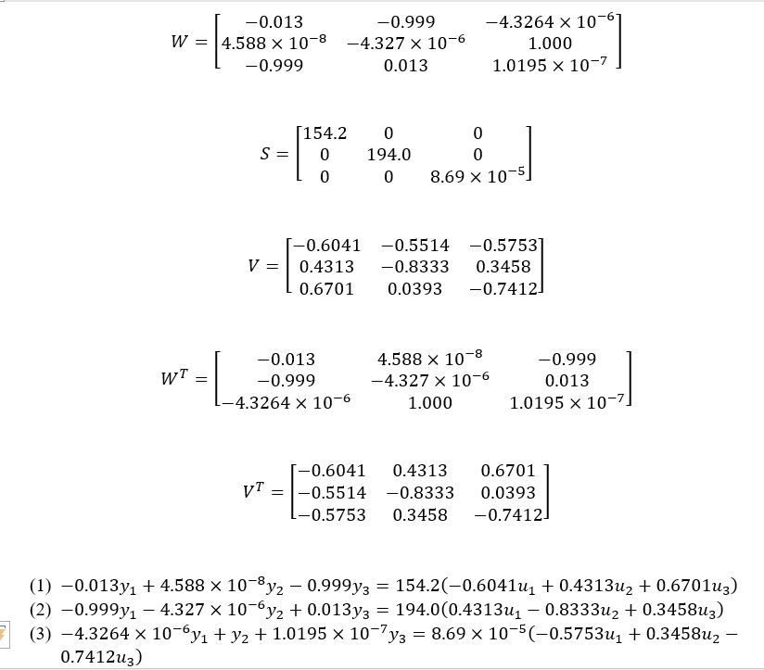

**Equation 1**: coefficient of y1 is the largest among the y’s and only u1 has the same negative sign as y1

→ y1 - u1 pairing

**Equation 2:** coefficient of y3 is the largest among the y’s and u2 has the larger in magnitude and negative sign as y3

→ y3 - u2 pairing

**Equation 3:** coefficient of y2 is the largest among the y’s but the condition number is significantly smaller than the other condition numbers, which indicates that it is difficult to control y2

1. **SVD-Based Controller Design and Implementation**

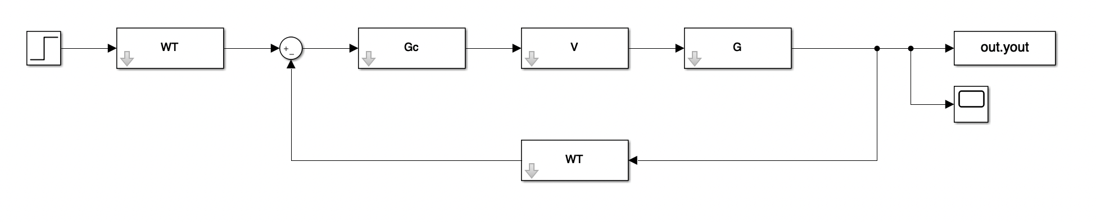

**Figure x.** SVD-Based Controller Design Implemented in SIMULINK and MATLAB.

1. **SVD-Based Controller Performance Evaluation**

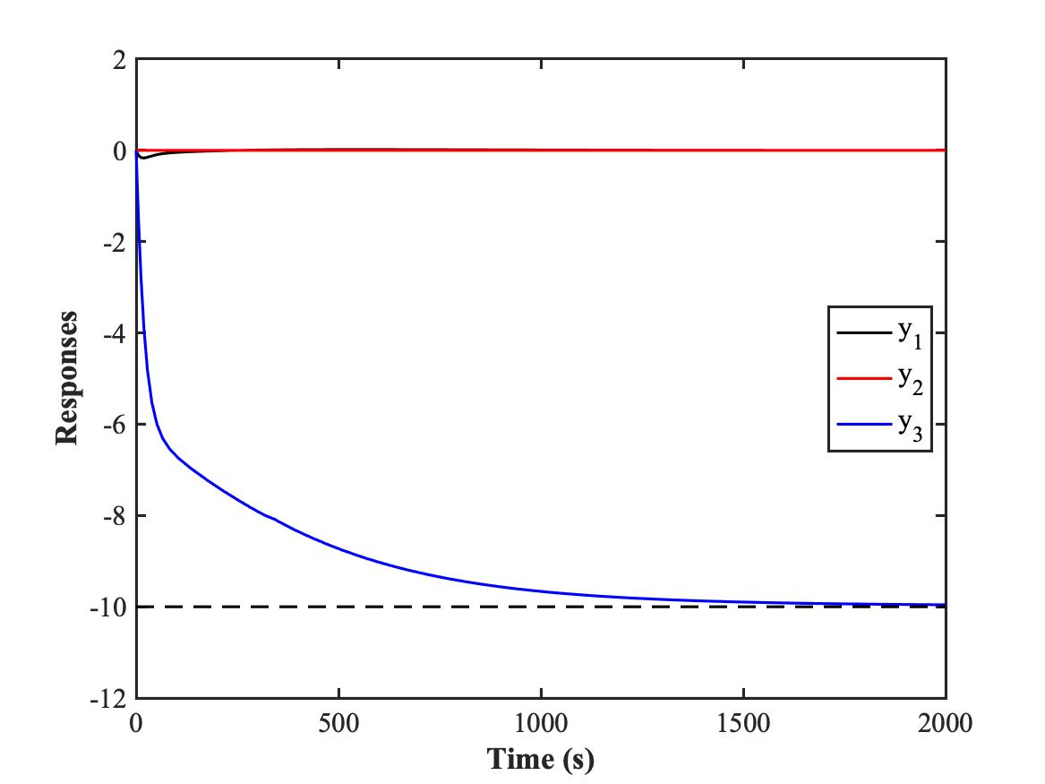

**Figure M.** Responses in y1, y2, and y3 Over Time for SVD-Based Controllers.

From **Figure M**, it could be seen that the response in y3 approaches -10 as expected. It took the response about 2000 s ( ~33 mins) to reach steady state. The change in yd3 from 0 to -10 is expected to affect y3. However, it also has an effect on y1, where there is a slight decrease in response at the beginning (around 20 s) before it goes back up and remains plateau around 0. At the same time, there is no change in y2 at all, indicating that yd3 has no effect on y2.